* Please create a folder under “SimulationDataVisualization” repository named “AEP Project” and put the code for all these figures there.

|  |  |
| --- | --- |
| A) | B) |
| C) | D) |
| **Figure 1: Validation of model** | |

|  |  |
| --- | --- |
| A) | B) |
| **Figure 2: Estimated prevalence of AEP** | |

|  |  |
| --- | --- |
| A) | B) |
| C) | D) |
| **Figure S2: Additional figures for model validation** | |

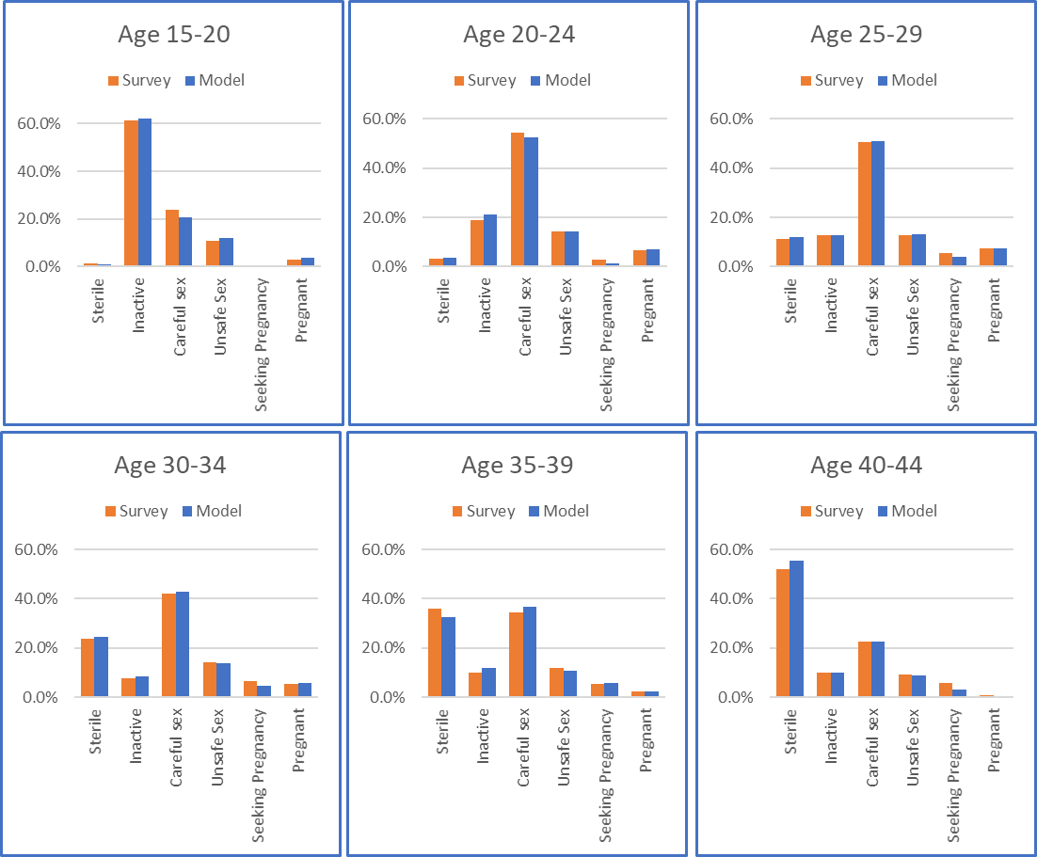

**Figure S1: Distribution of population members in age and sexual-behavior groups**